**Viewing & Modifying Index Policies using Azure Portal-Data Explorer**

**DEMO PREP:**

**Viewing Index Policies:**

1. Create a CosmosDB account with Core (SQL) API.
2. In CosmosDB, as opposed to relational DB, every document is indexed by default. Any collection documents have indexes in all the properties in the document. To find index policy, open the db in Azure Portal. From Data Explorer pane select container to work on. Drill down to *Settings*.

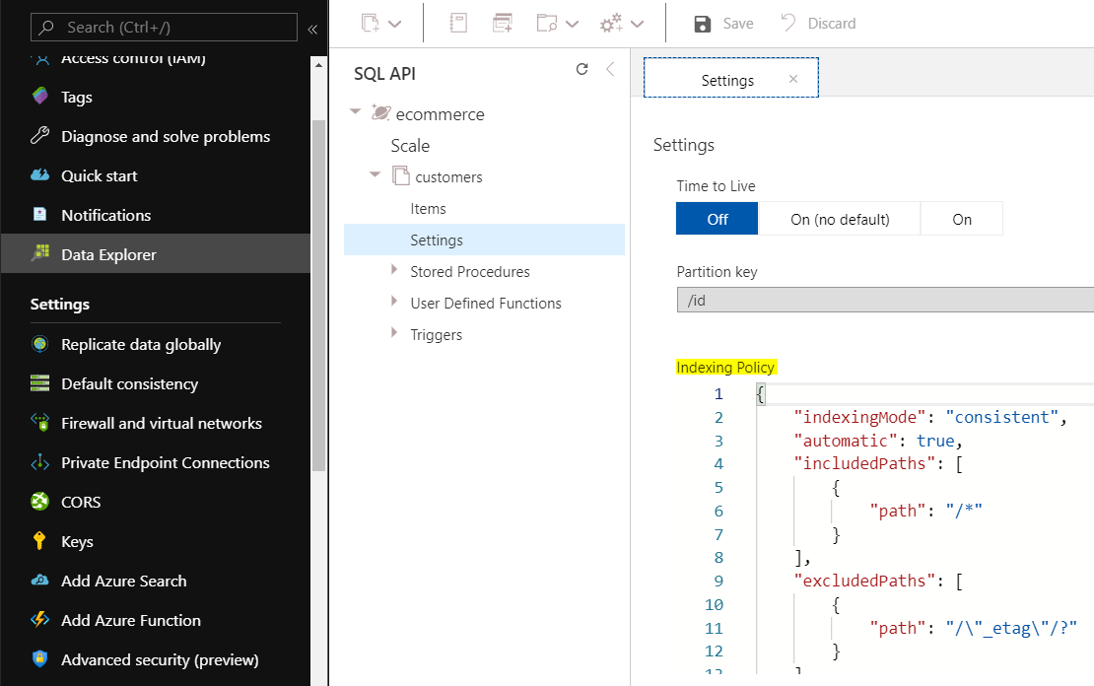

1. Every container has an index policy which is defined by the following properties:
   1. The index mode is consistent, defined by *IndexingMode*.
   2. Documents are indexed automatically, defined by *automatic* property.
   3. All properties are indexed, defined by *IncludedPaths*.

**Modifying Index Policies:**

1. Can be updated at any time using Azure portal or one of the supported SDKs.
2. Open DB from Azure Portal. From Data Explorer pane select container to work on. Under Settings. Modify the index policy JSON document. Click Save when done.

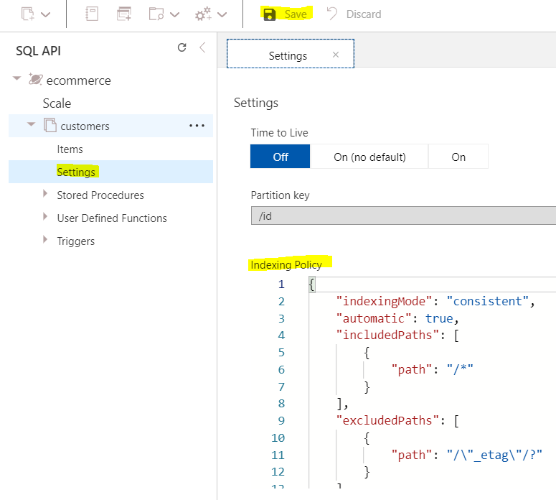

Note: an update to the index policy triggers a transformation from the old index to the new one, which is performed online and in place (no additional storage space is consumed during operation). Index transformation is asynchronous operation, the time it takes to complete depends on provisioned throughput, number of items and size.